Chirayu Rai

Assignment 1

Rough estimate of time: 1.5 hours

Started project at: 1:00 pm on Monday, October 9th. Finished at 3:29 on Monday, October 9th. (Roughly 2.5 hours)

* Requirements Analysis and Design
  + Started: 1:00 pm
  + Finished: 1:20 pm
  + Completed a full sketch of how application should work as well as an idea of the full tech stack.
  + 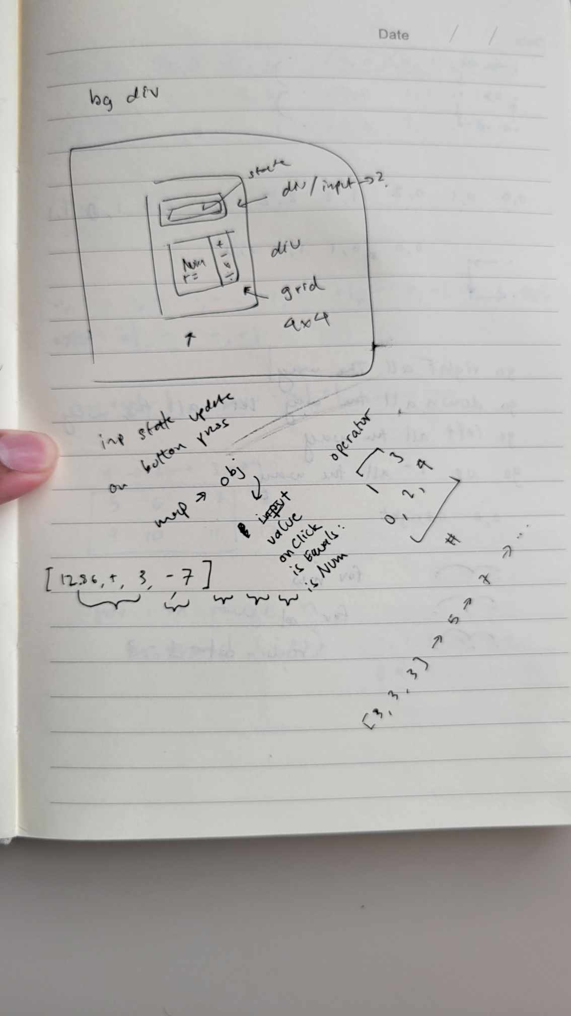
* Development
  + Started: 1:20 pm
  + Finished: 3:29 pm
* Testing
  + Started: 1:20 pm
  + Finished: 3:29 pm
  + Testing was not very rigorous, just made sure negatives and positives work, as well as some other general chaining and such. Also ensured that clearing the code would run as intended.
  + Bugs and fixes: 4 total
    - This was more an issue with the environment, but my libraries were clashing and not functioning properly until I configured them correctly. It took half an hour to figure out why things were not going well.
    - Negative numbers weren’t working with my original implementation, until I used the “parseInt” function from javascript. This allowed negative numbers to be registered as, well, negative numbers thus making the code work as intended
    - Originally, user could not chain answers with new operations (like 1 + 1 = 2, and then using that 2 do 2 + 4 = 6) because of type casting errors. I was not setting the state of the input back to a string, so we had incompatible types of the input being a mishmash of strings and integers, leading to bugs. Typecasting the result back to a string solved this error.
    - The input or answer div was not rendering when it was blank. To solve this, I conditionally rendered either a placeholder string or the input state depending on if the input state is empty.
  + Comparing time
    - I originally thought I could get this done quite quickly if I gave myself enough RnD time to tackle the problem. And, to be fair, the longest bug by far was the environment one. If I had set everything up correctly from the get go, I might have actually been able to complete the project in about an hour. Just goes to show that having a solid foundation is really important.